**Simplilearn-_Phase_-2_-project-_FSJD-_ Learner’s Academy**

**Input/output Screens**

**Admin Login Page**

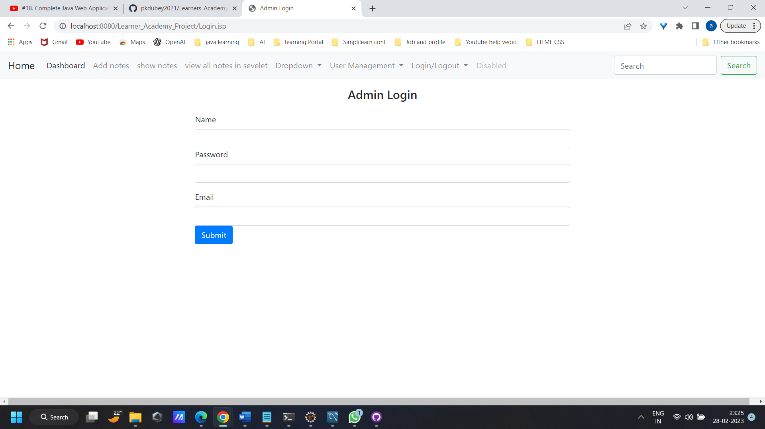

**Add /Manage user users**

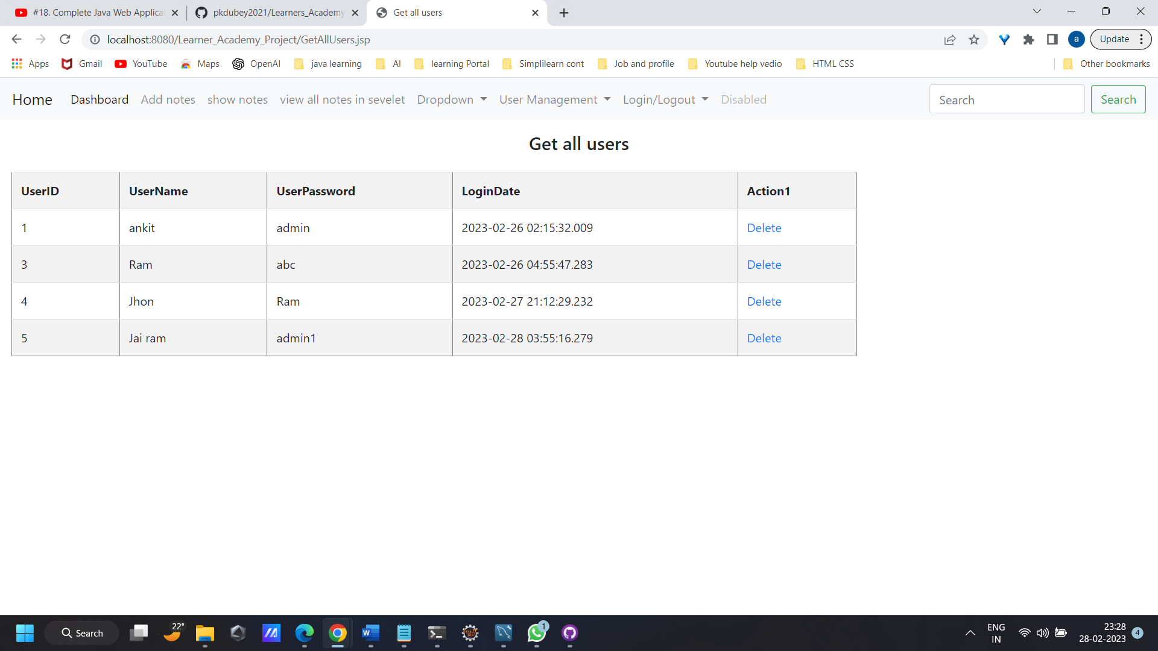

**Add new use**

